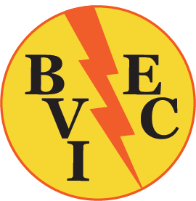

Invitation to Tender
Construction of Solar Streetlight Bases

BVI Electricity Corporation invites qualified contractors to tender for the construction of solar streetlight bases at various locations in the British Virgin Islands.
Project Overview:
The selected contractor will construct solar streetlight bases in the area/s and quantities identified below. Base construction should be done in accordance with the provided drawings and specifications.
The locations and quantities are as follows:

- Main Road to North Sound - 15 lights
- Pockwood Pond to Coxheath - 24 lights
- Sunny Caribbee - 2 lights
- Admin Drive - 5 lights
- Jost Van Dyke - 4 lights
- Anegada - 15 lights

Tenderers should submit separate breakdown of costs for each location and an overall cost for areas tendered.

Submission Requirements (Interested tenderers are required to submit the following documents):
1. The completed Bill of Quantities as provided.
2. A List of projects undertaken by the Tenderer within the past (5) years that demonstrate the Tenderer’s experience in delivering similar projects.
3. A list of Current Contract Commitments/Work in Progress.
4. A detailed Work Programme and Method Statement showing the order in which the various sections of works are to be executed, timelines for completion and the rates of progress.
5. A copy of valid Trade License.
6. Any other materials required to be completed and submitted in accordance with the Instructions to Tenderers embodied in these Tender Documents.

Submission Deadline:
All tenders must be submitted no later than 10:00 a.m. local time on Friday 8th March 2024. Tenders received after this date and time will not be acknowledged.

Submission Address:
Please submit tenders in a sealed envelope to BVIEC at our Long Bush Office:
Attn: General Manager
BVI Electricity Corporation
Lon Bush, Tortola
British Virgin Islands
Telephone: (284) 852-4600
Re: Tender for Solar Streetlight Base Construction

Evaluation and Selection Process:
The procurement process will follow the Open Tendering process.
Project Timeline:
The project is expected to begin 25th March 2024, and is expected to be completed on or before 30th April 2024.
Disclaimer:
BVI Electricity Corporation does not bind itself to accept the lowest price or any other submission. The Corporation reserves the right to cancel this notice, either in part or in its entirety, without incurring any costs for tenderers who have submitted their proposals.

